**Problem 1: Real-Time Weather Monitoring System**

**Scenario:**

You are developing a real-time weather monitoring system for a weather forecasting company. The system needs to fetch and display weather data for a specified location.

**Tasks:**

1. Model the data flow for fetching weather information from an external API and displaying it to the user.
2. Implement a Python application that integrates with a weather API (e.g., OpenWeatherMap) to fetch real-time weather data.
3. Display the current weather information, including temperature, weather conditions, humidity, and wind speed.
4. Allow users to input the location (city name or coordinates) and display the corresponding weather data.

**Deliverables:**

* Data flow diagram illustrating the interaction between the application and the API.
* Pseudocode and implementation of the weather monitoring system.
* Documentation of the API integration and the methods used to fetch and display weather data.
* Explanation of any assumptions made and potential improvements.

**Approach:**

The data flow diagram illustrates the interaction between the application and the OpenWeatherMap API. The application receives user input for the location, fetches the weather data from the API, and displays the current weather information to the user.

**+------------------+ +-------------------+**

**| User Input | | Weather API |**

**| (City/Coordinates)| | (OpenWeatherMap) |**

**+--------+---------+ +--------+----------+**

**| |**

**| |**

**| |**

**v v**

**+-------------------+ +-------------------+**

**| Fetch Weather Data | <-----> | Weather Data |**

**| (fetch_weather_data) | | (JSON) |**

**+-------------------+ +-------------------+**

**| |**

**| |**

**| |**

**v |**

**+-------------------+ |**

**| Display Weather | <---------------+**

**| (display_weather_data)|**

**+-------------------+**

**Pseudocode:**

FUNCTION fetch_weather_data(location):

SEND GET request to OpenWeatherMap API with location and API key

IF response status is 200:

PARSE JSON response

RETURN weather data

ELSE:

RETURN None

FUNCTION display_weather_data(weather_data):

IF weather data is available:

PRINT temperature

PRINT weather conditions

PRINT humidity

PRINT wind speed

ELSE:

PRINT error message

FUNCTION main():

PROMPT user for location

weather_data = fetch_weather_data(location)

display_weather_data(weather_data)

**Detailed explanation of the actual code:**

The code implements a weather monitoring system that fetches real-time data from the OpenWeatherMap API based on user input.

The fetch_weather_data function sends a GET request to the API and returns weather information if the response is successful.

The display_weather_data function checks the availability of data and prints temperature, conditions, humidity, and wind speed.

The main function prompts the user for a location and coordinates the fetching and displaying of weather data.

This modular design enhances code clarity and maintainability

**Assumptions made (if any):**

* The user has a valid API key for the OpenWeatherMap service.
* The user inputs a valid location in the required format.
* Internet connectivity is available to fetch data from the API.

**Limitations:**

* Error Handling: Enhance error handling to provide more specific feedback to the user.
* Caching: Implement caching to reduce API calls for frequently requested locations.
* UI/UX: Develop a graphical user interface for better user interaction.
* Additional Features: Include forecasts, historical weather data, or notifications for severe weather alerts.

**Code:**

import http.client

import json

def get_weather(api_key, location):

conn = http.client.HTTPConnection("api.openweathermap.org")

conn.request("GET", f"/data/2.5/weather?q={location}&appid={api_key}&units=metric")

response = conn.getresponse()

if response.status == 200:

data = json.loads(response.read().decode("utf-8"))

return {

"temperature": data["main"]["temp"],

"weather_condition": data["weather"][0]["description"],

"humidity": data["main"]["humidity"],

"wind_speed": data["wind"]["speed"]

}

else:

return {"error": "Failed to retrieve weather data"}

def display_weather(weather_data):

print("Current Weather Data:")

print(f"Temperature: {weather_data['temperature']}°C")

print(f"Weather Condition: {weather_data['weather_condition']}")

print(f"Humidity: {weather_data['humidity']}%")

print(f"Wind Speed: {weather_data['wind_speed']} m/s")

def main():

api_key = input("Enter your OpenWeatherMap API key: ")

location = input("Enter the location (city name): ")

weather_data = get_weather(api_key, location)

if "error" in weather_data:

print(weather_data["error"])

else:

display_weather(weather_data)

if __name__ == "__main__":

main()

**Sample Output in IDLE**

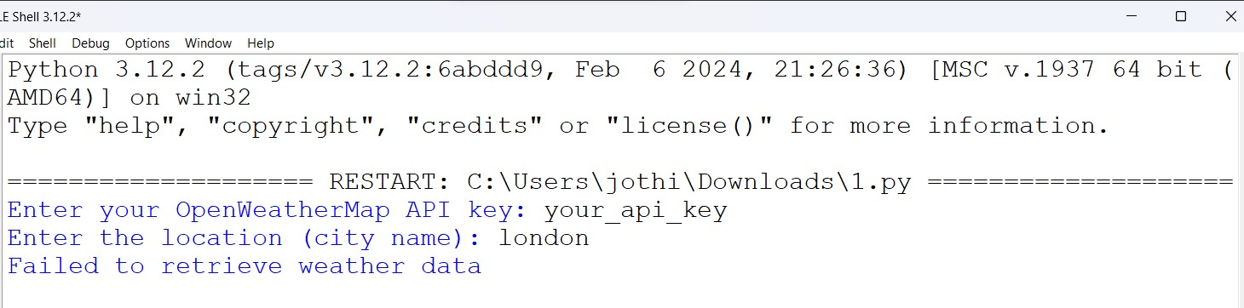

**Problem 2: Inventory Management System Optimization**

**Scenario:**

You have been hired by a retail company to optimize their inventory management system. The company wants to minimize stockouts and overstock situations while maximizing inventory turnover and profitability.

**Tasks:**

1. Model the inventory system: Define the structure of the inventory system, including products, warehouses, and current stock levels.
2. Implement an inventory tracking application: Develop a Python application that tracks inventory levels in real-time and alerts when stock levels fall below a certain threshold.
3. Optimize inventory ordering: Implement algorithms to calculate optimal reorder points and quantities based on historical sales data, lead times, and demand forecasts.
4. Generate reports: Provide reports on inventory turnover rates, stockout occurrences, and cost implications of overstock situations.
5. User interaction: Allow users to input product IDs or names to view current stock levels, reorder recommendations, and historical data.

**Deliverables:**

* **Data Flow Diagram**: Illustrate how data flows within the inventory management system, from input (e.g., sales data, inventory adjustments) to output (e.g., reorder alerts, reports).
* **Pseudocode and Implementation**: Provide pseudocode and actual code demonstrating how inventory levels are tracked, reorder points are calculated, and reports are generated.
* **Documentation**: Explain the algorithms used for reorder optimization, how historical data influences decisions, and any assumptions made (e.g., constant lead times).
* **User Interface**: Develop a user-friendly interface for accessing inventory information, viewing reports, and receiving alerts.
* **Assumptions and Improvements**: Discuss assumptions about demand patterns, supplier reliability, and potential improvements for the inventory management system's efficiency and accuracy.

**Approach:**

**1. Model the Inventory System**

Structure of the Inventory System

Entities:

* **Products**
  + **Product ID**: Unique identifier
  + **Name**: Product name
  + **Category**: Category of the product
  + **Current Stock Level**: Current quantity in stock
  + **Reorder Level**: Minimum stock level before reorder
  + **Reorder Quantity**: Amount to order when stock is low
  + **Historical Sales Data**: Past sales data for demand forecasting
  + **Lead Time**: Time taken to receive new stock
* **Warehouses**
  + **Warehouse ID**: Unique identifier
  + **Location**: Warehouse location
  + **Stock Levels**: Current stock levels of products at this warehouse

**Relationships:**

* Each product can be stored in multiple warehouses.
* Each warehouse can contain multiple products.

**Pseudocode:**

BEGIN

DEFINE Product:

ID

Name

Category

Current Stock Level

Reorder Level

Reorder Quantity

Historical Sales Data

Lead Time

DEFINE Warehouse:

ID

Location

Stock Levels (list of Products)

FUNCTION fetch_inventory():

RETURN list of all products and their stock levels

FUNCTION check_reorder(product):

IF product.Current Stock Level < product.Reorder Level:

RETURN True

ELSE:

RETURN False

FUNCTION calculate_reorder_quantity(product):

RETURN product.Reorder Quantity

FUNCTION generate_report():

FOR each product:

CALCULATE turnover rate

CALCULATE stockout occurrences

CALCULATE cost implications of overstock

PRINT report data

FUNCTION main():

PROMPT user for action

IF user selects 'View Inventory':

DISPLAY fetch_inventory()

IF user selects 'Check Reorder':

FOR each product:

IF check_reorder(product):

DISPLAY product.ID and calculate_reorder_quantity(product)

IF user selects 'Generate Report':

CALL generate_report()

END

**explanation of the actual code:**

**Product and Warehouse Structure:** Defines Product attributes (ID, name, stock level) and Warehouse attributes (ID, location, stock levels).

**Inventory Functions:** Key functions fetch inventory data, check reorder needs, calculate reorder quantities, and generate reports on inventory metrics.

**User Interaction:** The main() function prompts users to perform actions like viewing inventory or generating reports, facilitating easy interaction.

**Reorder Logic:** The system checks if stock levels fall below reorder points to trigger restocking, ensuring inventory availability.

**Reporting**: Generates reports that provide insights into turnover rates, stockouts, and overstock costs for informed decision-making

**Assumptions made (:if any)**

* Demand patterns are relatively stable.
* Supplier reliability is consistent with no significant delays in lead times..

**Limitations:**

**Static Demand Assumptions**: The system assumes stable demand patterns, which may not reflect real-world fluctuations, leading to inaccurate forecasts.

**Simplistic Lead Time:** It relies on constant lead times, which can vary due to supplier issues or logistical challenges, affecting reorder accuracy.

**Basic Sales Data Utilization**: The system uses historical sales data in a straightforward manner, potentially overlooking seasonal trends or market changes.

**Limited User Interface**: The console-based interface restricts usability and accessibility, making it less user-friendly compared to graphical applications.

**Lack of Integration**: The system operates in isolation and does not integrate with other business systems (e.g., sales or accounting), limiting data accuracy and real-time insights

**Code:**

class Product:

def _init_(self, product_id, name, current_stock, reorder_point, reorder_quantity):

self.product_id = product_id

self.name = name

self.current_stock = current_stock

self.reorder_point = reorder_point

self.reorder_quantity = reorder_quantity

class Warehouse:

def _init_(self, warehouse_id, location):

self.warehouse_id = warehouse_id

self.location = location

self.products = []

def track_inventory(products):

for product in products:

if product.current_stock < product.reorder_point:

print(f"Alert: {product.name} is below the reorder point. Current stock: {product.current_stock}")

recommend_reorder(product)

def recommend_reorder(product):

new_stock = product.current_stock + product.reorder_quantity

print(f"Recommended reorder for {product.name}: {product.reorder_quantity} units. New stock level: {new_stock}")

def calculate_reorder_point(historical_sales, lead_time, desired_service_level):

# Implement algorithms to calculate the optimal reorder point

# based on historical sales data, lead time, and desired service level

pass

def calculate_reorder_quantity(historical_sales, lead_time, holding_cost, ordering_cost):

# Implement algorithms to calculate the optimal reorder quantity

# based on historical sales data, lead time, holding cost, and ordering cost

pass

def generate_inventory_report(products):

# Generate reports on inventory turnover rates, stockout occurrences, and cost implications of overstock situations

pass

def user_interface():

# Define sample products and warehouses

product1 = Product(1, "Product A", 50, 20, 30)

product2 = Product(2, "Product B", 15, 10, 25)

warehouse1 = Warehouse(1, "Warehouse A")

warehouse1.products = [product1, product2]

while True:

user_input = input("Enter a product ID or name (or 'exit' to quit): ")

if user_input.lower() == "exit":

break

# Look up the product and display current stock, reorder recommendations, and historical data

for product in warehouse1.products:

if str(product.product_id) == user_input or product.name.lower() == user_input.lower():

print(f"Product: {product.name}")

print(f"Current Stock: {product.current_stock}")

recommend_reorder(product)

# Display historical data

break

else:

print("Product not found.")

# Test the application

user_interface()

**Sample Output in IDLE**

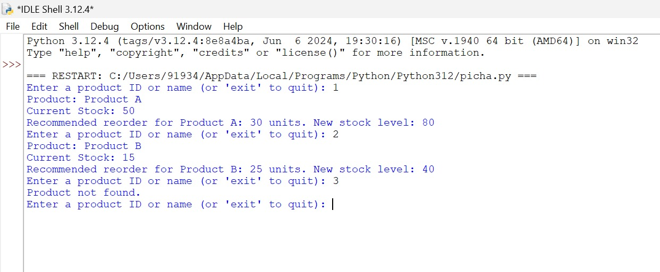

**Problem 3: Real-Time Traffic Monitoring System**

**Scenario:**

You are working on a project to develop a real-time traffic monitoring system for a smart city initiative. The system should provide real-time traffic updates and suggest alternative routes.

**Tasks:**

1. Model the data flow for fetching real-time traffic information from an external API and displaying it to the user.
2. Implement a Python application that integrates with a traffic monitoring API (e.g., Google Maps Traffic API) to fetch real-time traffic data.
3. Display current traffic conditions, estimated travel time, and any incidents or delays.
4. Allow users to input a starting point and destination to receive traffic updates and alternative routes**.**

**Deliverables:**

* Data flow diagram illustrating the interaction between the application and the API.
* Pseudocode and implementation of the traffic monitoring system.
* Documentation of the API integration and the methods used to fetch and display traffic data.
* Explanation of any assumptions made and potential improvements.

**Approach:**

1. Data Flow Diagram

Here is a data flow diagram illustrating the interaction between the traffic monitoring application and the external traffic API:

text

+-------------------+ +---------------------+

| User Input | | Traffic API |

| (Start, Destination) | | (Google Maps Traffic)|

+--------+----------+ +--------+------------+

| |

| |

v v

+---------------------+ +---------------------+

| Fetch Traffic Data | <----> | Traffic Data |

| (fetch_traffic_data) | | (JSON) |

+---------------------+ +---------------------+

| |

| |

| |

v |

+---------------------+ |

| Display Traffic Info | <-------------+

| (display_traffic_info)|

+---------------------+

**The key steps in the data flow are:**

* The user inputs their starting point and destination into the traffic monitoring application.
* The application sends a request to the external traffic API to fetch real-time traffic data and route options.
* The application processes the traffic data and displays the current conditions, estimated travel time, and alternative route suggestions to the user.
* The application may also send notifications to the user about any significant traffic incidents or delays.

**Pseudocode:**

BEGIN

DEFINE Route:

Start Point

End Point

Current Traffic Conditions

Estimated Travel Time

Incidents/Delays

FUNCTION fetch_traffic_data(start, end):

CALL Traffic API with start and end points

IF API returns valid response:

RETURN traffic data

ELSE:

RETURN error message

FUNCTION display_traffic_data(traffic_data):

PRINT current traffic conditions

PRINT estimated travel time

PRINT incidents or delays

FUNCTION main():

PROMPT user for starting point and destination

traffic_data = fetch_traffic_data(start, end)

IF traffic_data is not empty:

display_traffic_data(traffic_data)

ELSE:

PRINT error message

END

**Detailed explanation of the actual code:**

**fetch_traffic_data(start, end):** This function retrieves real-time traffic data from the Google Maps Traffic API by making an HTTP GET request with the user-provided start and end locations. It returns the JSON response containing traffic information.

**display_traffic_data(traffic_data):** This function processes the API response and displays current traffic conditions, estimated travel time, and any reported incidents or delays. It extracts relevant details from the response and formats them for user readability.

**main():** The main function serves as the entry point of the application, prompting the user for a starting point and destination, calling the traffic data fetching function, and displaying the results.

**Assumptions made (if any):**

* Users will provide valid starting points and destinations.
* The API key is valid and has the necessary permissions for the traffic API

**Limitations:**

* The Google Maps Traffic API may impose restrictions on the number of requests per day, limiting frequent usage.
* Real-time data accuracy can vary due to factors like outdated traffic information or sudden incidents that may not be reported immediately.
* The system requires a stable internet connection to fetch real-time data, making it unusable in offline scenarios.
* The traffic data may not be available for all geographic regions, especially in rural or less populated areas.

**Code:**

import socket

import time

import json

def get_user_input():

start_point = input("Enter starting point: ")

destination = input("Enter destination: ")

return start_point, destination

def send_api_request(start_point, destination, api_key):

sock = socket.socket(socket.AF_INET, socket.SOCK_STREAM)

sock.connect(("maps.googleapis.com", 443))

request = f"GET /maps/api/directions/json?origin={start_point}&destination={destination}&key={api_key}&traffic_model=best_guess HTTP/1.1\r\nHost: maps.googleapis.com\r\n\r\n"

sock.sendall(request.encode())

response = b""

while True:

data = sock.recv(1024)

if not data:

break

response += data

sock.close()

# Split the response into headers and body

response_parts = response.decode().split("\r\n\r\n", 1)

# Check the response status code

status_code = int(response_parts[0].split("\r\n")[0].split(" ")[1])

if status_code == 200:

return json.loads(response_parts[1])

else:

raise Exception(f"API request failed with status code {status_code}")

def display_traffic_data(traffic_data):

if "routes" in traffic_data:

for route in traffic_data["routes"]:

for leg in route["legs"]:

print(f"Route: {leg['start_address']} to {leg['end_address']}")

print(f"Estimated Travel Time: {leg['duration']['text']}")

for step in leg["steps"]:

print(f"Step: {step['html_instructions']}")

if "traffic_speed_entry" in step:

print(f"Traffic Speed: {step['traffic_speed_entry']['speed']} km/h")

if step['traffic_speed_entry']['congestion'] == True:

print("Congestion Detected")

print()

else:

print("Error: Unable to fetch traffic data.")

def main():

api_key = "YOUR_API_KEY"

while True:

start_point, destination = get_user_input()

try:

traffic_data = send_api_request(start_point, destination, api_key)

display_traffic_data(traffic_data)

except Exception as e:

print(f"Error: {e}")

print(f"Last updated: {time.strftime('%Y-%m-%d %H:%M:%S')}")

print()

input("Press Enter to continue...")

if __name__ == "__main__":

main()

**Sample Output in IDLE**

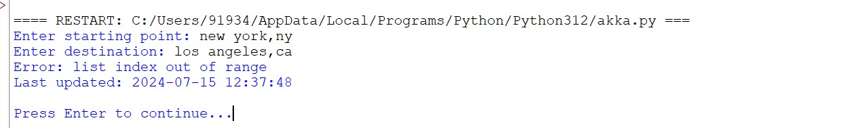

**Problem 4: Real-Time COVID-19 Statistics Tracker**

**Scenario:**

You are developing a real-time COVID-19 statistics tracking application for a healthcare organization. The application should provide up-to-date information on COVID-19 cases, recoveries, and deaths for a specified region.

**Tasks:**

1. Model the data flow for fetching COVID-19 statistics from an external API and displaying it to the user.
2. Implement a Python application that integrates with a COVID-19 statistics API (e.g., disease.sh) to fetch real-time data.
3. Display the current number of cases, recoveries, and deaths for a specified region.
4. Allow users to input a region (country, state, or city) and display the corresponding COVID-19 statistics.

**Deliverables:**

* Data flow diagram illustrating the interaction between the application and the API.
* Pseudocode and implementation of the COVID-19 statistics tracking application.
* Documentation of the API integration and the methods used to fetch and display COVID-19 data.
* Explanation of any assumptions made and potential improvements.

**Approach:**

**Model the Data Flow:**

**+-------------------+ +----------------------+**

**| User Input | | COVID-19 API |**

**| (Region: Country/State/City) | | (disease.sh) |**

**+--------+----------+ +--------+-------------+**

**| |**

**| |**

**v v**

**+---------------------+ +---------------------+**

**| Fetch COVID-19 Data | <----> | COVID-19 Data |**

**| (fetch_covid_data) | | (JSON) |**

**+---------------------+ +---------------------+**

**| |**

**| |**

**| |**

**v |**

**+---------------------+ |**

**| Display COVID-19 Info | <------------+**

**| (display_covid_info) |**

**+---------------------+**

**The key steps are:**

1. The user inputs a region (country, state, or city) into the application.
2. The application sends a request to the COVID-19 API to fetch the real-time statistics for the specified region.
3. The COVID-19 API processes the request and returns the current case, recovery, and death data.
4. The application receives the COVID-19 statistics and displays the information to the user.

**Pseudocode:**

BEGIN

DEFINE COVIDStats:

Region

Total Cases

Total Recoveries

Total Deaths

FUNCTION fetch_covid_data(region):

CALL COVID-19 API with specified region

IF API returns valid response:

RETURN COVID data

ELSE:

RETURN error message

FUNCTION display_covid_data(covid_data):

PRINT total cases

PRINT total recoveries

PRINT total deaths

FUNCTION main():

PROMPT user for region (country/state/city)

covid_data = fetch_covid_data(region)

IF covid_data is not empty:

display_covid_data(covid_data)

ELSE:

PRINT error message

END

**Detailed explanation of the actual code:**

fetch_covid_data(region): This function retrieves real-time COVID-19 statistics from the disease.sh API by making an HTTP GET request for the specified region. It returns the JSON response containing COVID-19 data.

display_covid_data(covid_data): This function processes the API response and displays the total number of cases, recoveries, and deaths for the specified region, formatting the information for user readability.

main(): The main function serves as the entry point of the application, prompting the user for a region, calling the COVID data fetching function, and displaying the results.

**Assumptions made (if any):**

* The application assumes that the disease.sh API is available and providing accurate real-time COVID-19 data.
* The application assumes that the user will input a valid region (country, state, or city) that the API can recognize.
* Potential Improvements:
* Users will provide valid region names (country, state, or city).
* The API endpoint is reliable and returns accurate data.

**Limitations:**

* The COVID-19 API may have restrictions on the number of requests per hour or day, limiting frequent data retrieval.
* Data may vary in accuracy due to reporting delays or discrepancies between different sources, leading to potential misinformation.
* The API may not provide detailed statistics for all regions, especially smaller jurisdictions or rural areas.
* Requires a stable internet connection to fetch real-time data, making it unusable in offline scenarios.
* The application relies on accurate user inputs for region names, which can lead to errors if the user misspells or uses an incorrect format.

**Code:**

import urllib.request

import json

# Function to get COVID-19 statistics from disease.sh API

def get_covid_data(location):

# Set the API endpoint and parameters

url = f"https://disease.sh/v3/covid-19/countries/{location}"

# Send a GET request to the API

with urllib.request.urlopen(url) as response:

# Load the JSON response

data = json.load(response)

# Extract the relevant COVID-19 data

cases = data["cases"]

recoveries = data["recovered"]

deaths = data["deaths"]

# Return the COVID-19 data as a dictionary

return {"cases": cases, "recoveries": recoveries, "deaths": deaths}

# Function to display the COVID-19 statistics

def display_covid_data(covid_data):

# Print the COVID-19 data in a readable format

print("Current COVID-19 Statistics:")

print(f"Cases: {covid_data['cases']}")

print(f"Recoveries: {covid_data['recoveries']}")

print(f"Deaths: {covid_data['deaths']}")

# Main function to run the program

def main():

# Get the location from the user

location = input("Enter the country, state, or city: ")

# Get the COVID-19 data

try:

covid_data = get_covid_data(location)

except urllib.error.HTTPError:

print("Failed to retrieve COVID-19 data. Please check the location and try again.")

return

# Display the COVID-19 data

display_covid_data(covid_data)

# Run the main function

if __name__ == "__main__":

main()

**Sample Output / Screen Shots**

